**HINDUSTHAN COLLEGE OF ENGINEERING AND TECHNOLOGY**



**(AUTONOMOUS)**

|  |  |
| --- | --- |
| Date | 31st October 2022 |
| Team ID | PNT2022TMID34140 |
| Project Name | IOT Gas Leakage Monitoring and Alerting System. |
| Maximum Marks | 4 Marks |

**Data Flow Diagrams:**

A Data Flow Diagram (DFD) is a traditional visual representation of the information flows within a system. A neat and clear DFD can depict the right amount of the system requirement graphically. It shows how data enters and leaves the system, what changes the information, and where data is stored.

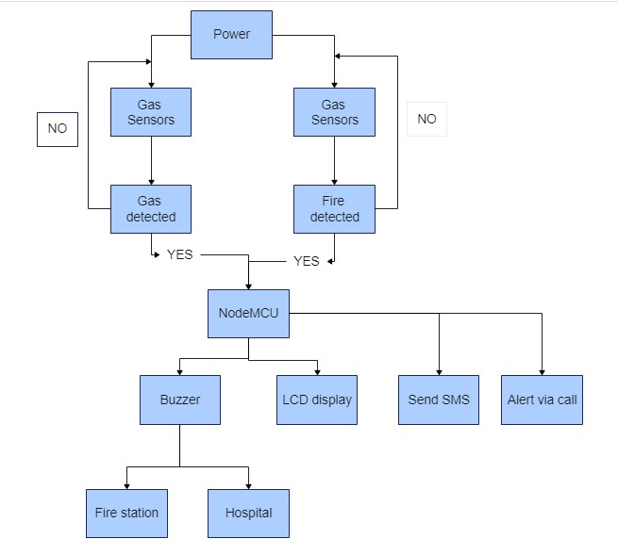

**User Stories**

Use the below template to list all the user stories for the product.

|  |  |  |  |  |  |  |
| --- | --- | --- | --- | --- | --- | --- |
| **User Type** | **Functional**  **Requirement (Epic)** | **User Story**  **Number** | **User Story / Task** | **Acceptance criteria** | **Priority** | **Release** |
| Customer  (Mobile user) | Registration | USN-1 | User can install the mobile application | I can access my account / dashboard | High | Sprint-1 |
|  |  | USN-2 | User can register their details like email and mobile number | I can receive confirmation email & click confirm | High | Sprint-1 |
|  | Login | USN-3 | User can log on to the application using email and password. | I can Login into my application | High | Sprint-1 |
|  | Dashboard | USN-4 | User can update their details like alternative mobile number etc.. | I can view and change my details. | High | Sprint-2 |
|  |  | USN-5 | User can view the gas level and the working condition of the sensors. | I can view the data given by the device | High | Sprint-2 |
| Customer (Web user) | Usage | USN-1 | User can register through the web page with e-mail or phone number. | I can receive confirmation email & click confirm | High | Sprint-3 |
|  |  | USN-2 | User can log on to the web page using email and password. | I can Login into my application | High | Sprint-3 |
| Customer | Working | USN-1 | User can view the details | Act according to the alarm | Medium | Sprint-3 |
|  |  | USN-2 | User can view the alert and turn off the power supply. | Act according to the alarm | High | Sprint-4 |
| Customer Care Executive | Action | USN-1 | Executer solves the user’s problem | I can solve the issues | High | Sprint-4 |
| Administrator | Administration | USN-1 | Periodic check the condition of sensors and  Stores the user’s information | I can maintain the fault tolerance and error rate | High | Sprint-4 |